[ved 7](https://www.youtube.com/watch?v=rGlJiUO-dZA&list=PLE7E8B7F4856C9B19&index=7)

Create the monster class from the video

========================================================================

<https://docs.oracle.com/javase/tutorial/java/javaOO/classes.html>

<https://docs.oracle.com/javase/tutorial/java/javaOO/classdecl.html>

<https://docs.oracle.com/javase/tutorial/java/javaOO/variables.html>

<https://docs.oracle.com/javase/tutorial/java/javaOO/methods.html>

<https://www.javatpoint.com/constructor>

<https://docs.oracle.com/javase/tutorial/java/javaOO/arguments.html>

<https://docs.oracle.com/javase/tutorial/java/javaOO/objects.html>

<https://docs.oracle.com/javase/tutorial/java/javaOO/objectcreation.html>

<https://docs.oracle.com/javase/tutorial/java/javaOO/usingobject.html>

## What is Java

Java is a **programming language** and a **platform**.

Java is a high level, robust, secured and object-oriented programming language.

**Platform**: Any hardware or software environment in which a program runs, is known as a platform. Since Java has its own runtime environment (JRE) and API, it is called platform.

Object in Java

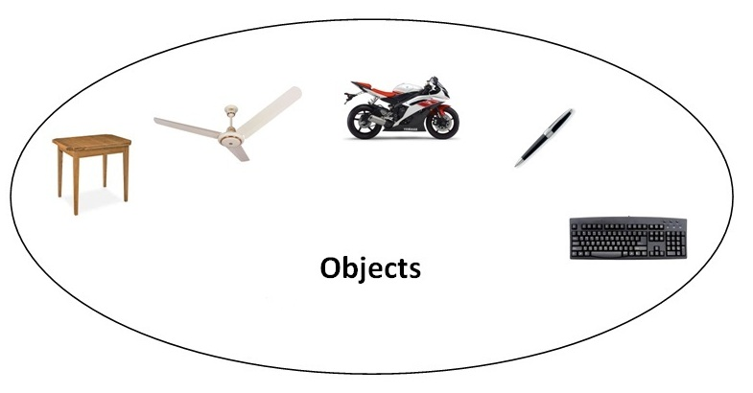

An entity that has state and behavior is known as an object e.g. chair, bike, marker, pen, table, car etc. It can be physical or logical (tangible and intangible). The example of intangible object is banking system.

# Small Exercise:

Create a class named Bicycle

Add what do you thing the variable and methods should be.